BIT4107 – Student Management App Report
Name: Virginia Munyori
Admission Number: BIT/2025/67506
Unit Code: BIT4107
Unit Name: Mobile Applications Development
1. Introduction
The Student Management App is a mobile application developed using the Flutter framework. The application is designed to help users manage student records efficiently through a simple and user-friendly interface.
The system allows users to add, view, and manage student information such as name, email, and course details. The application demonstrates key mobile development concepts including navigation, user interface design and data handling.
2.Objectives
The objectives of the project were:
To develop a mobile application using Flutter.
To implement navigation between multiple screens.
To manage student information.
To provide a user-friendly interface for viewing and managing student records.
3. System Features
The application includes the following features:
Splash Screen
Login Screen
Registration Screen
Dashboard
Add Student Screen
Student Profile Screen
4. Development Tools
The following tools were used:
Flutter SDK
Dart Programming Language
Android Studio / VS Code
GitHub

5. Screenshots
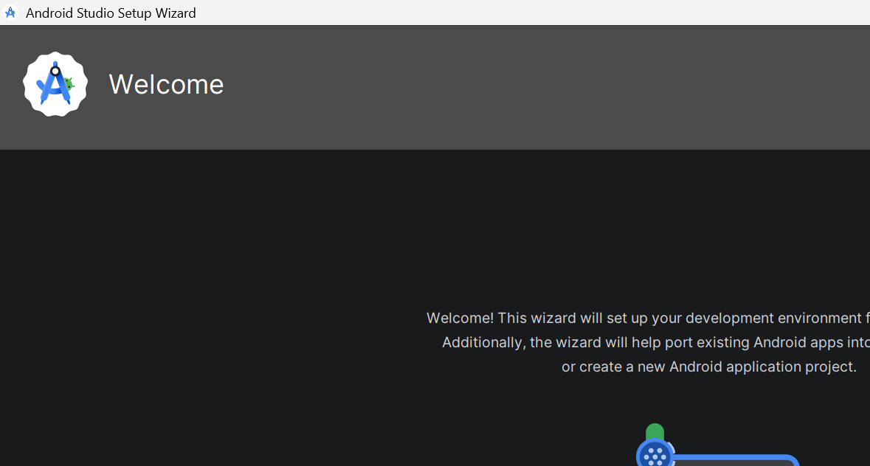
VS Code
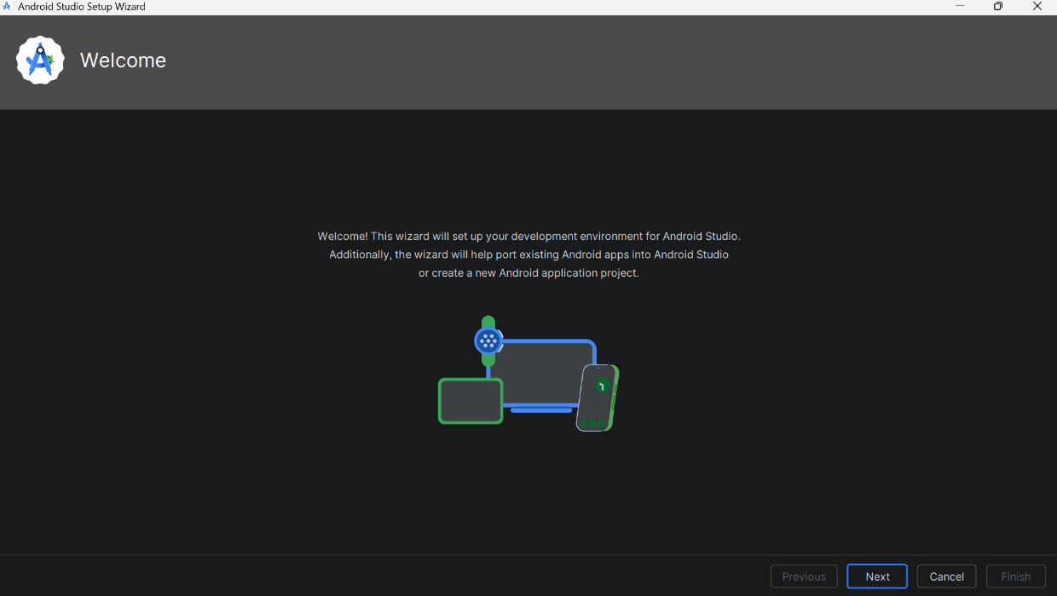
Android Studio
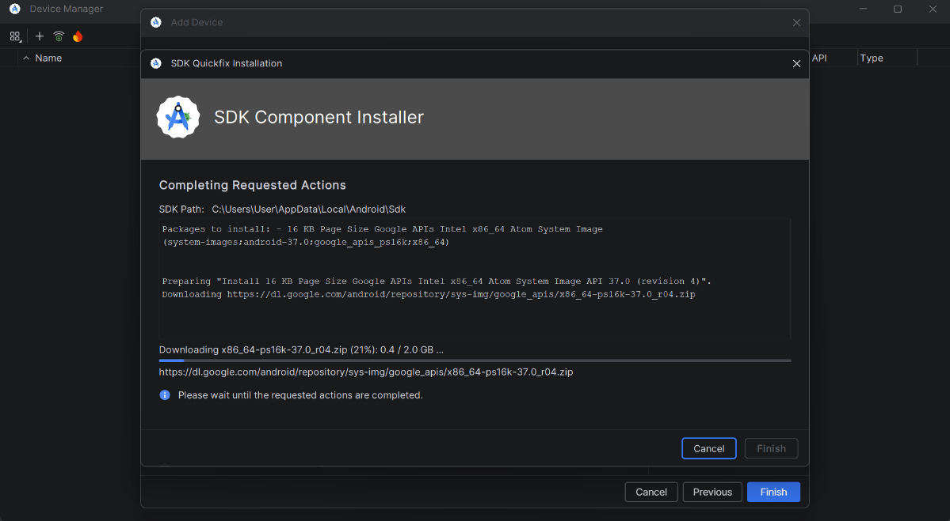
Flutter SDK

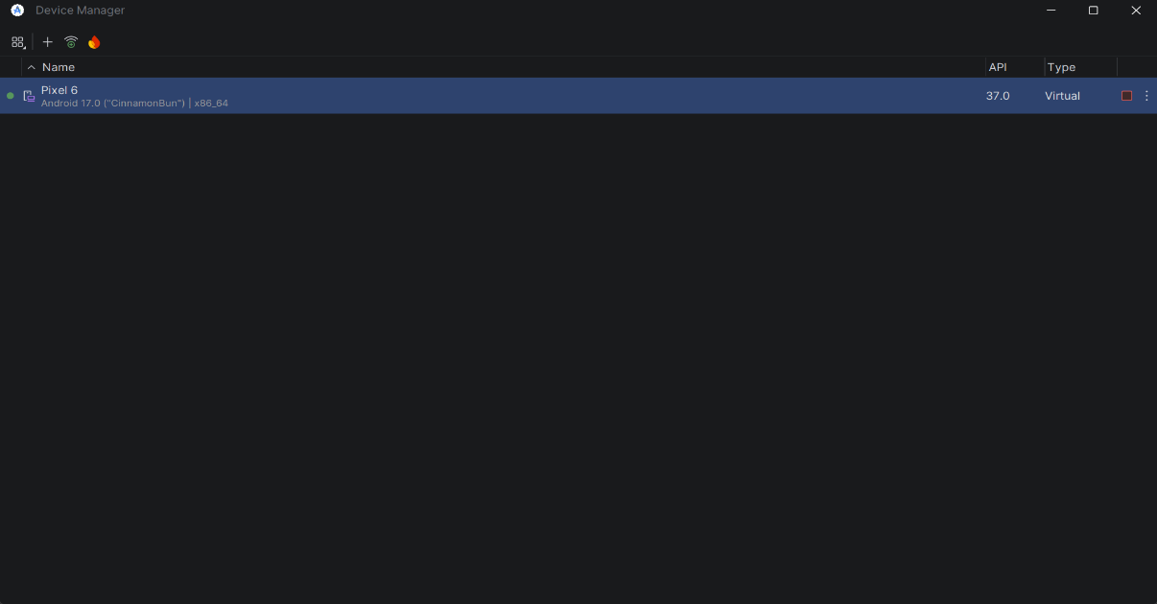
Emulator

Run
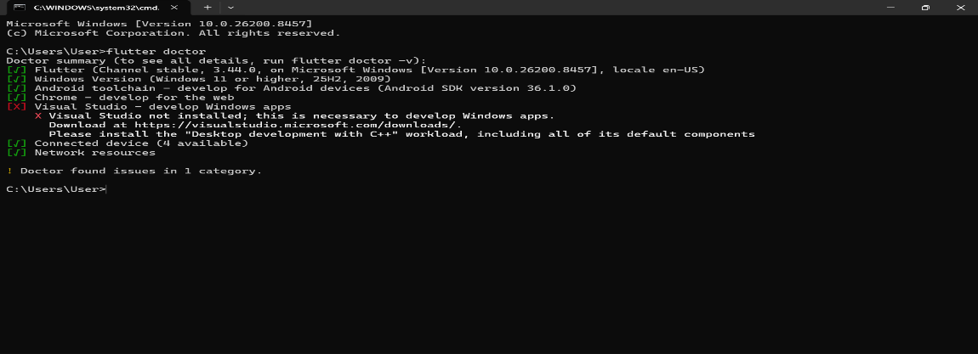
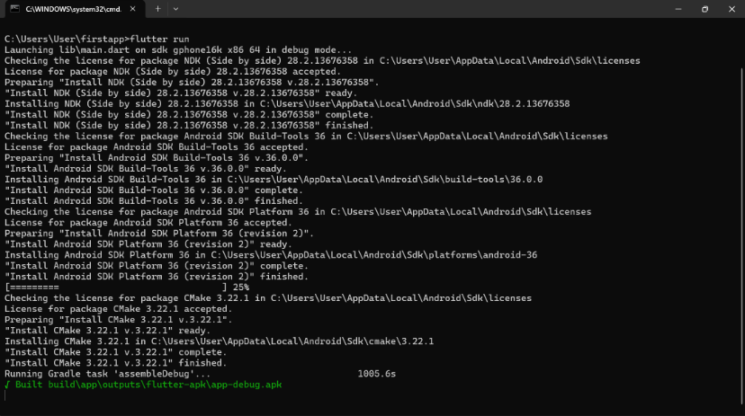
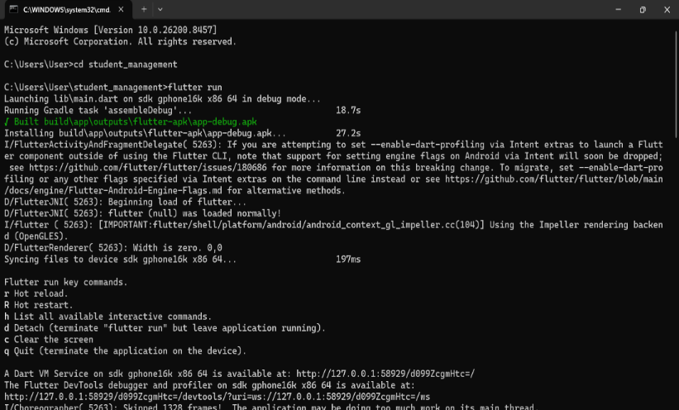

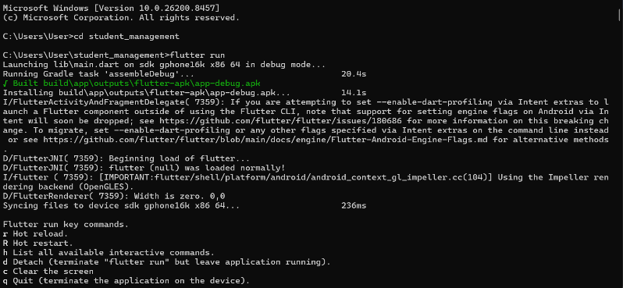
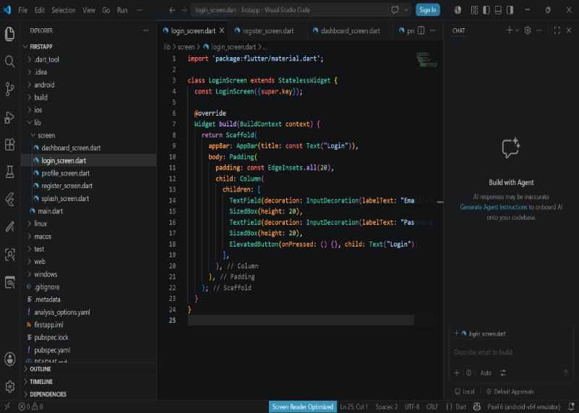
Student Login Screen
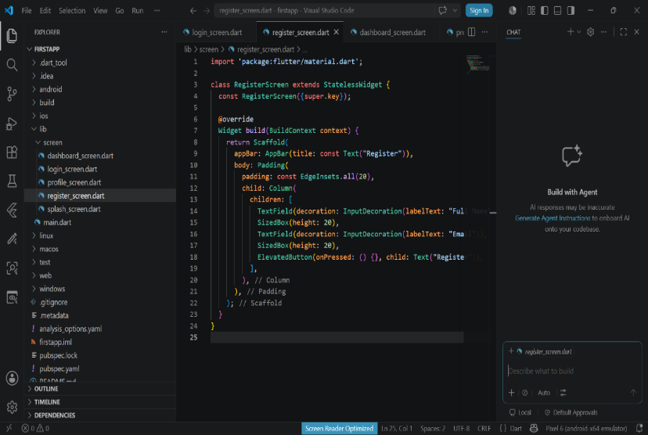
Registration screen
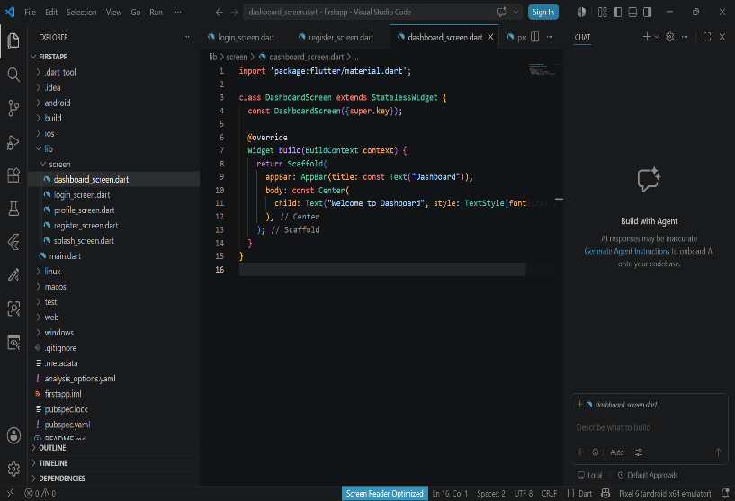
Dashboard Screen
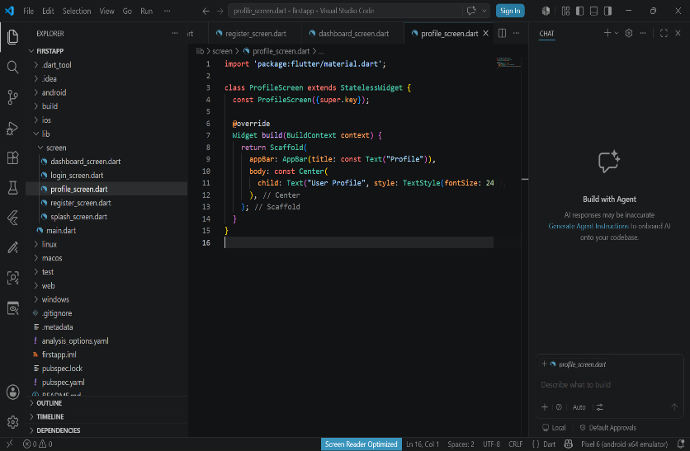
Profile Screen Code
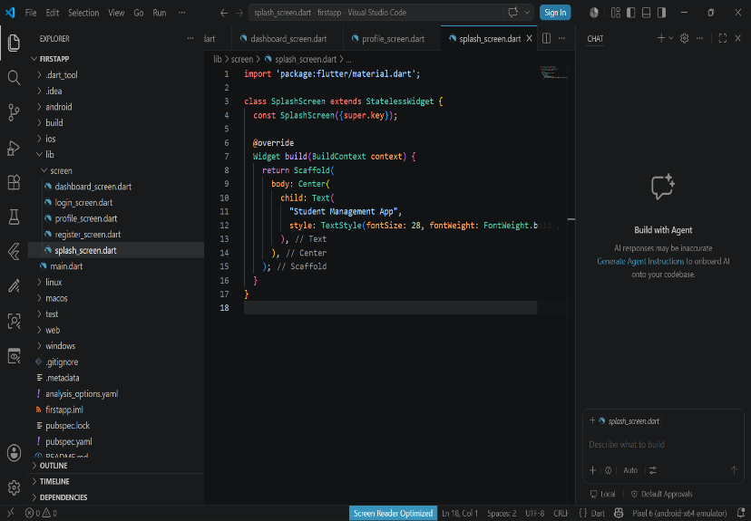
Splash Screen Code
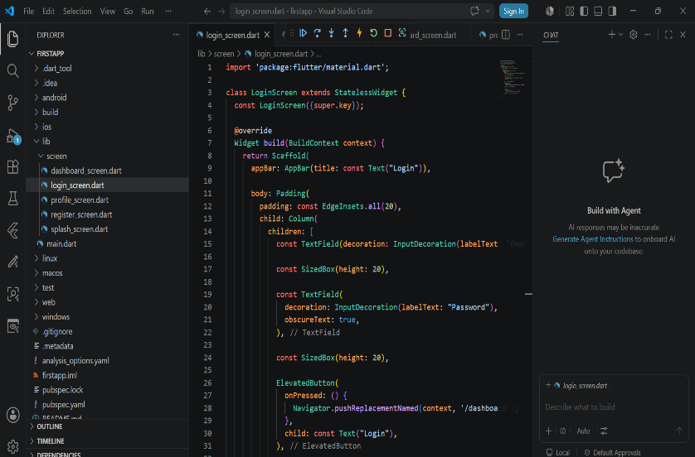
Login Screen Code
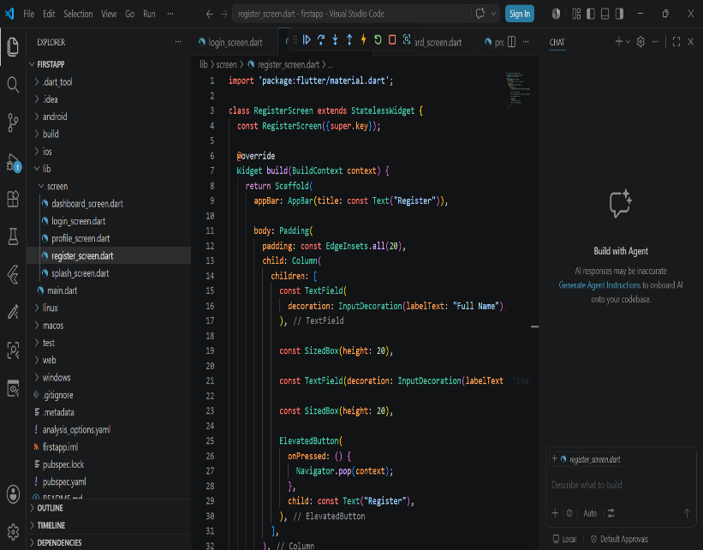
Registration Screen Code
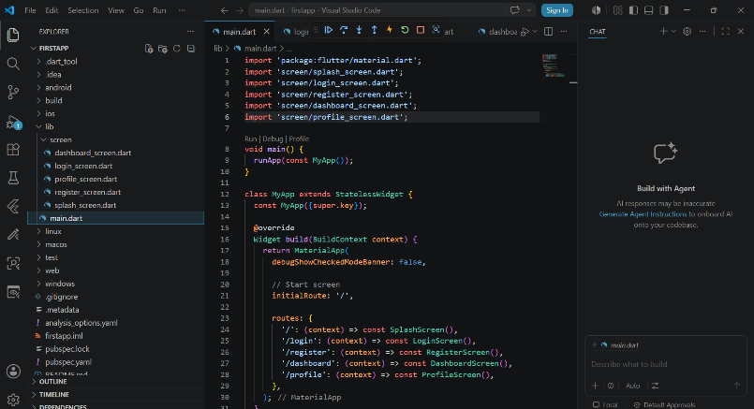
Main Dart
Mini Student App

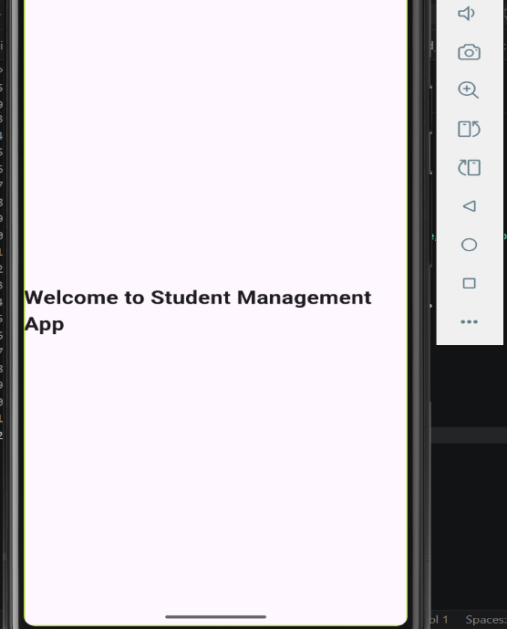
Dashboard

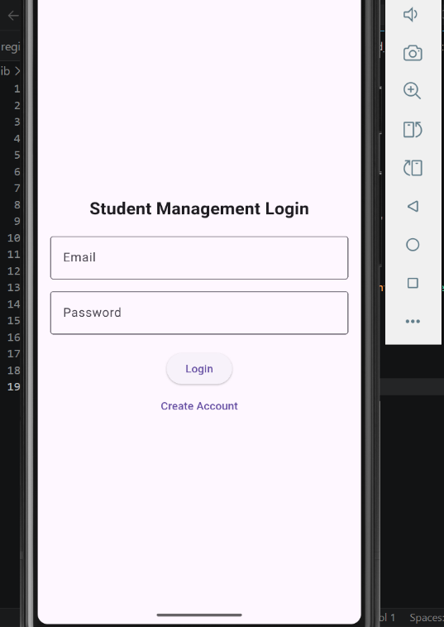
Login Screen

d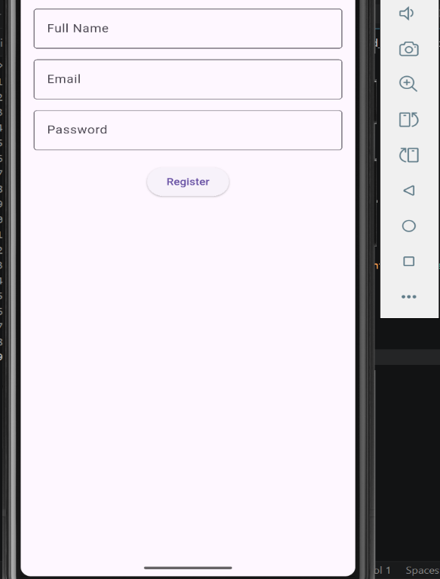
Registration Screen

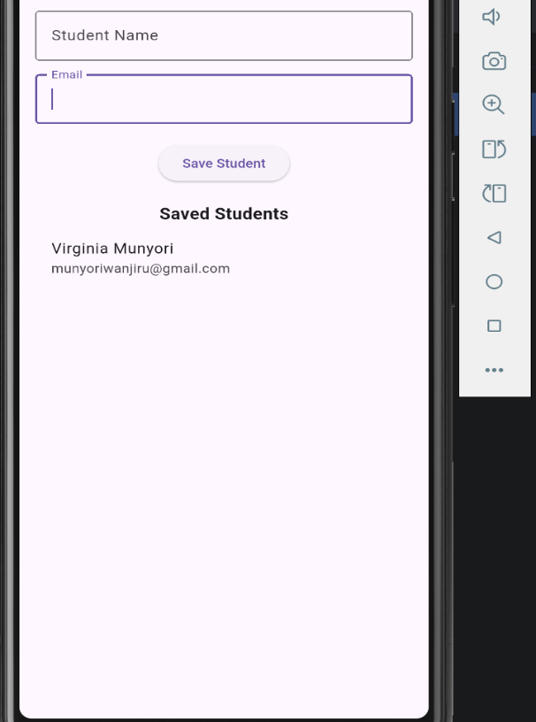
Details Saved

STUDENT MANAGEMENT APP

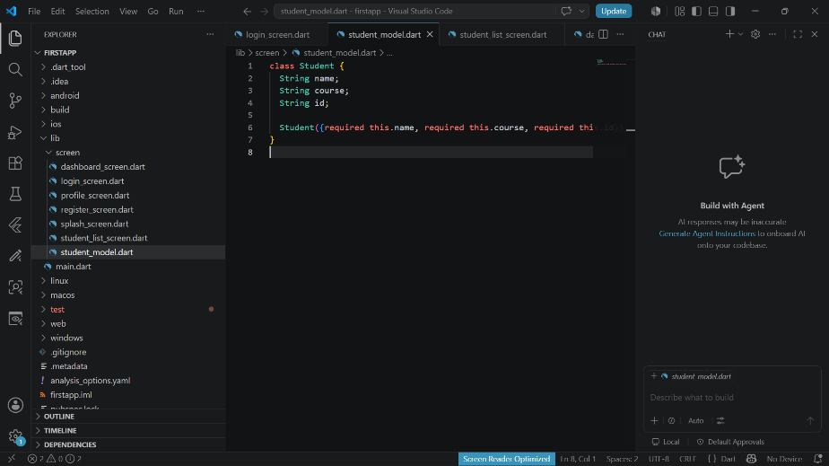

Student model code
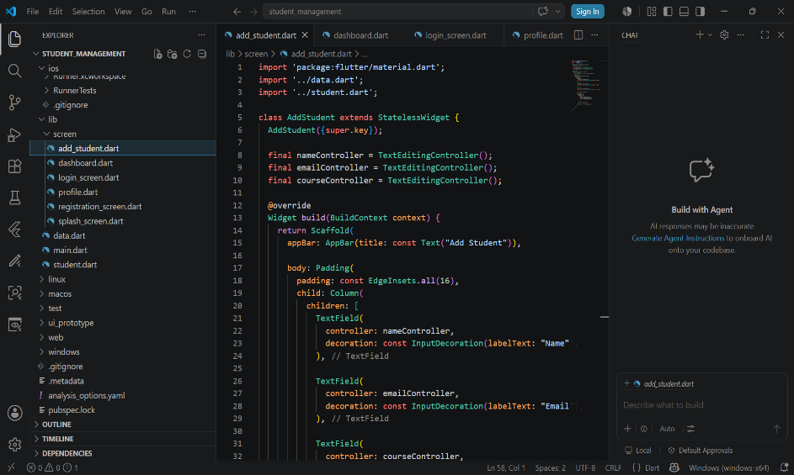
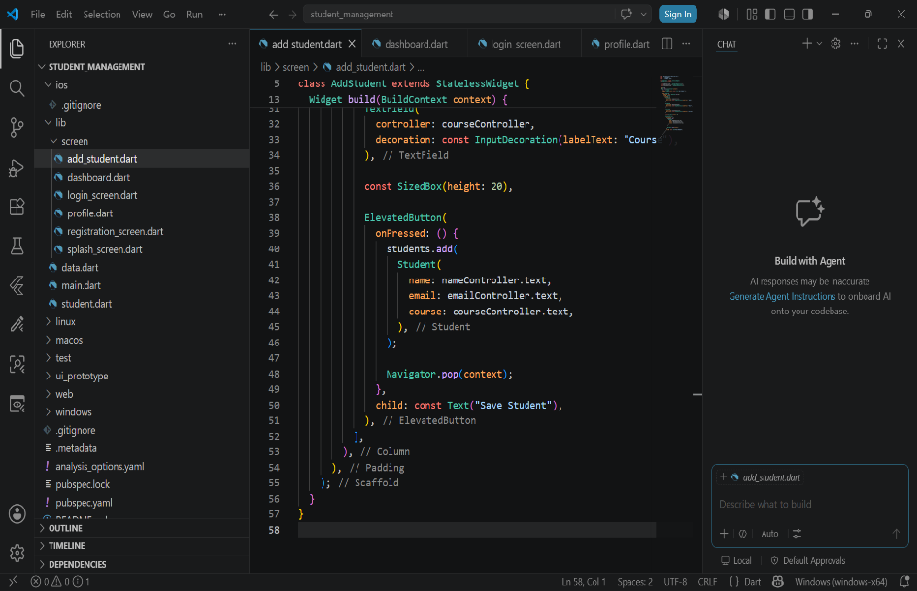
To add student code
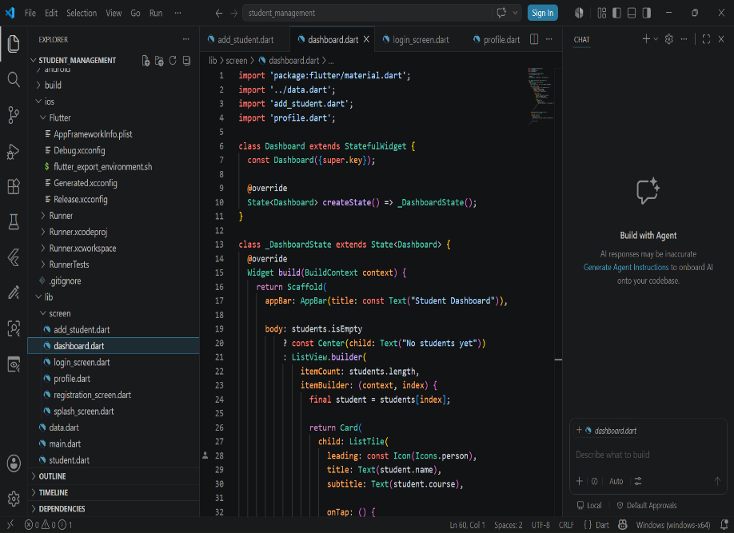
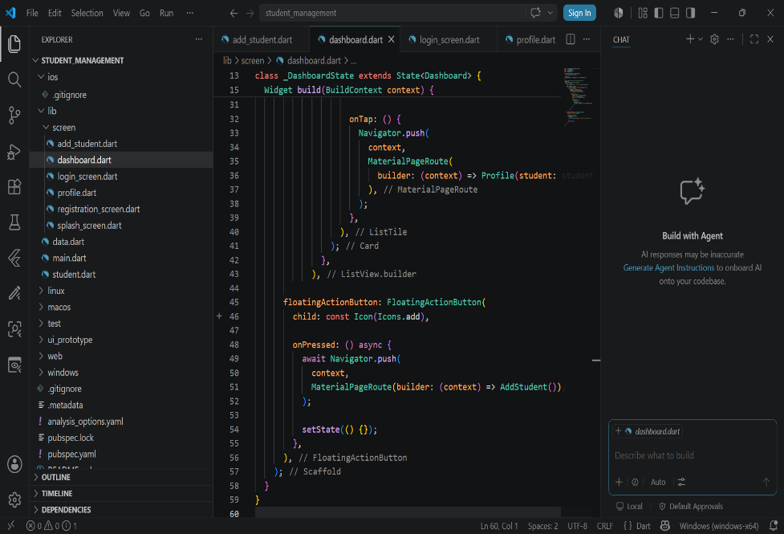
Dashboard screen code
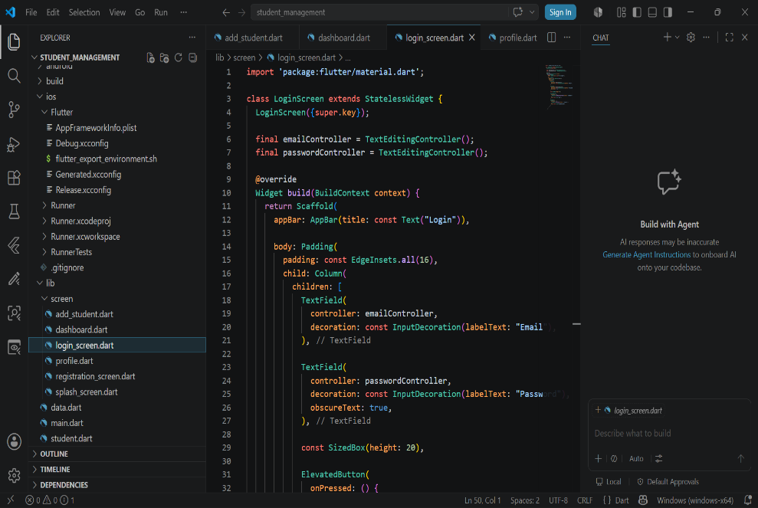
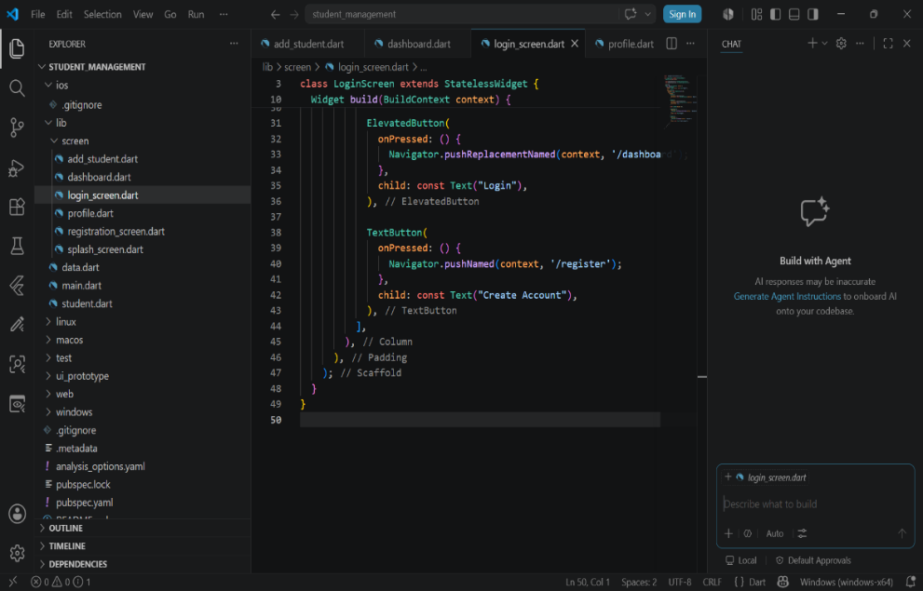
Login Screen Code
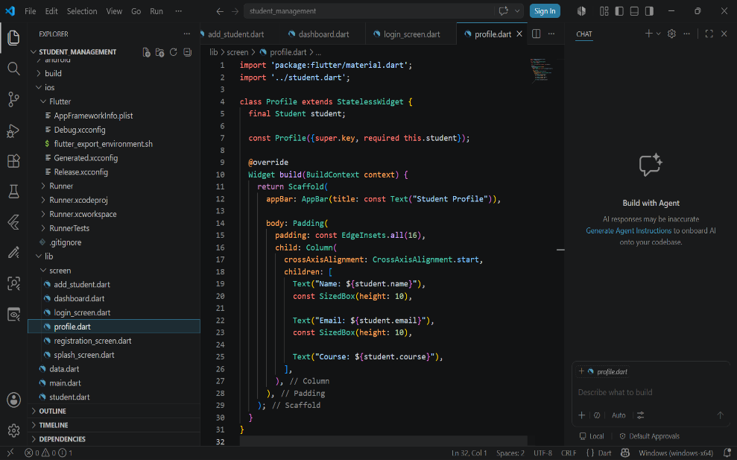
Profile Screen Code
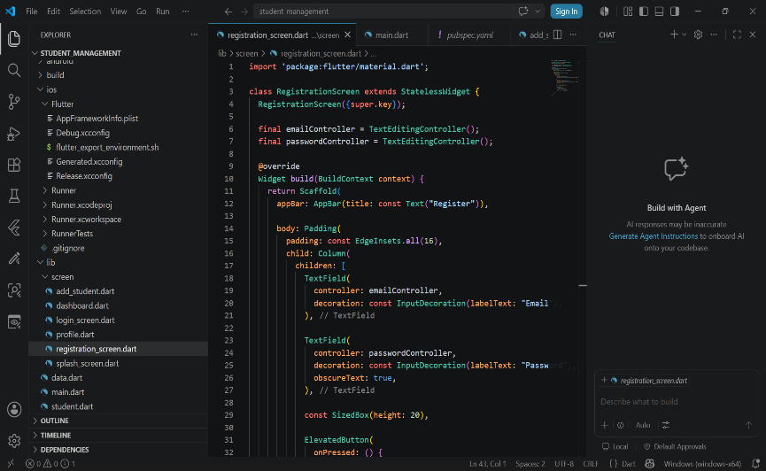
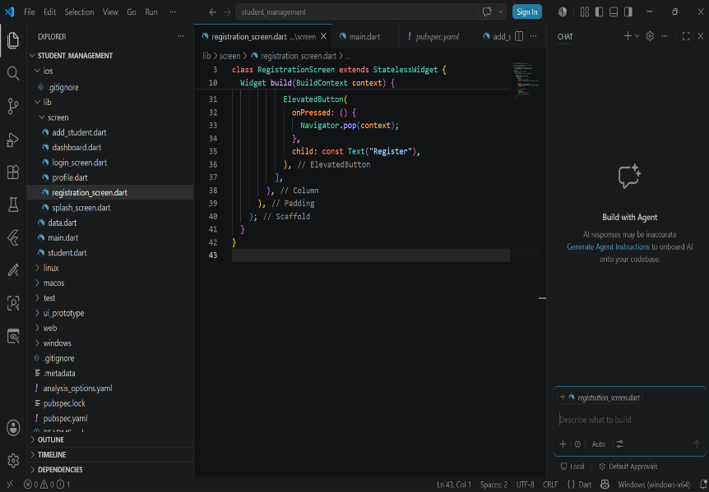
Registration Screen Code
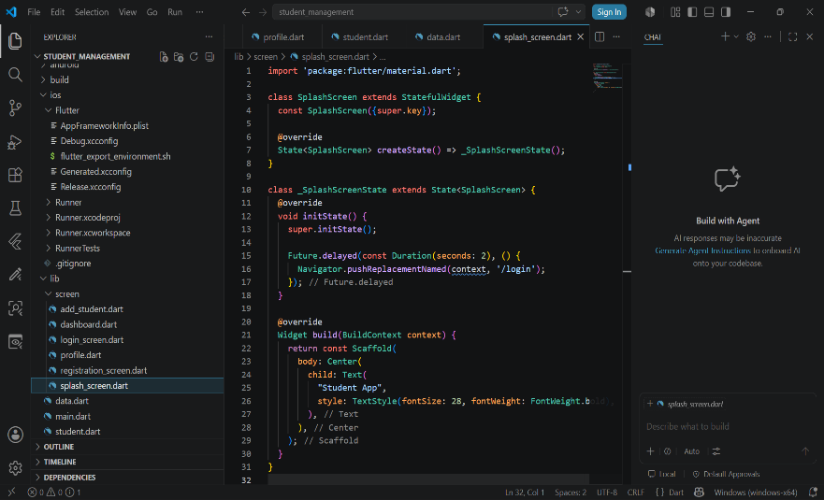
Splash Screen Code

The Student Management App includes the following features:

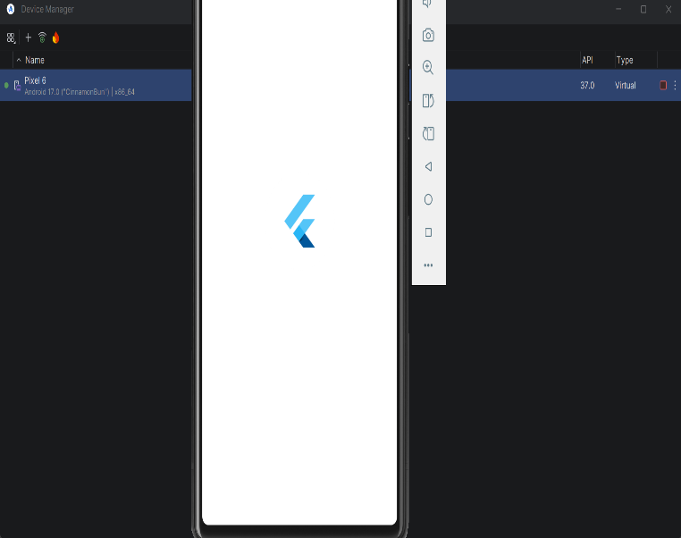
Figure 1: Splash Screen - Displays the application logo during startup

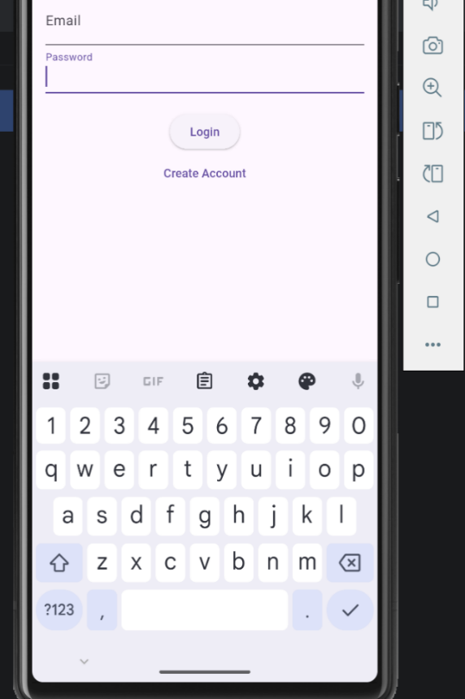
Figure 2: Login Screen - Allows users to log into the system

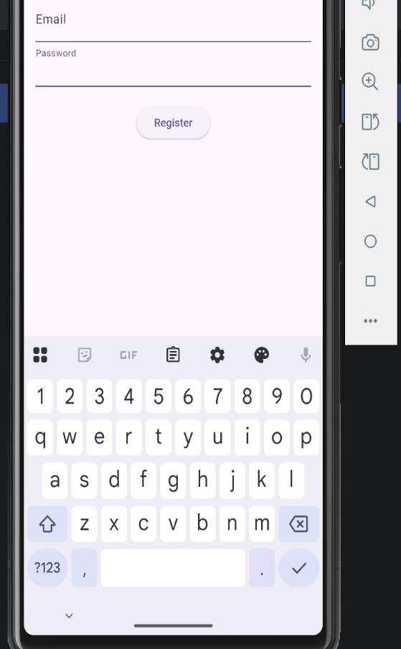
Figure 3: Registration Screen - Enables new users to create an account
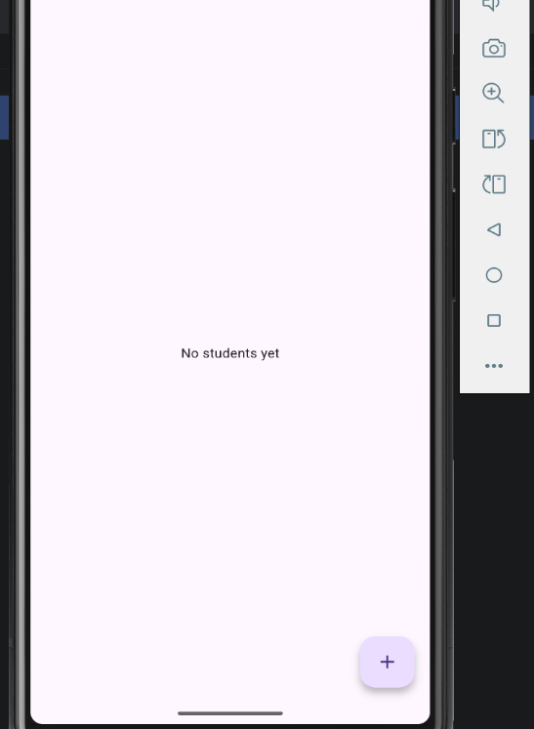
Figure 4: Dashboard Screen - Displays a list of all added students

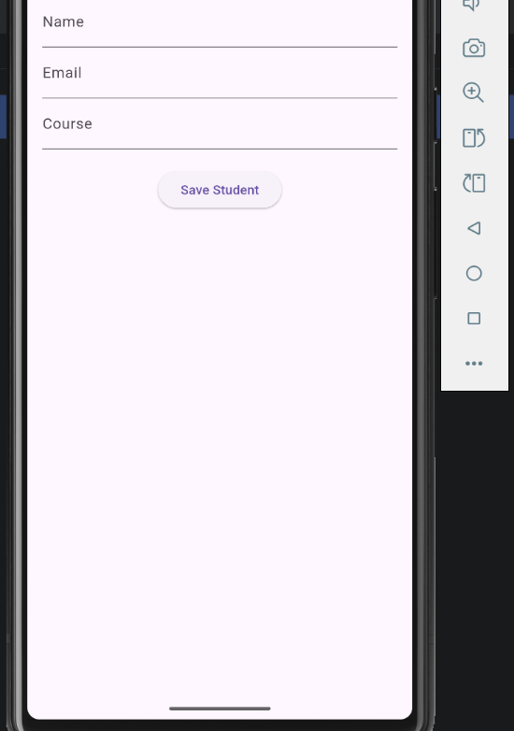
Figure 5: Profile Screen - Displays detailed information about a selected student

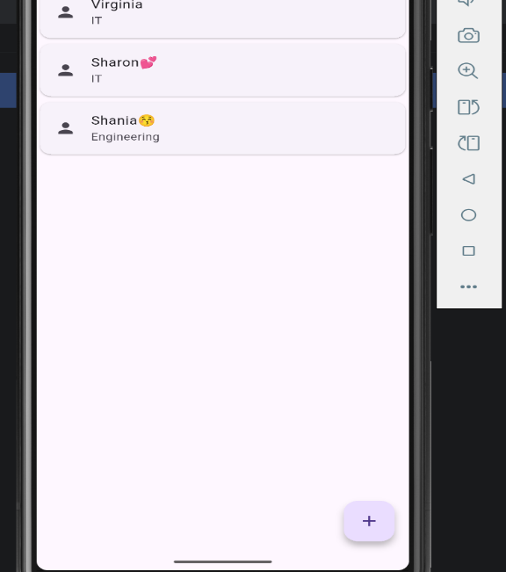
Figure 6: Students List - Displays detailed information about a selected student

6. Challenges Encountered
Navigation errors during development.
Import and routing issues.
Debugging Flutter build errors.
7. Conclusion
The project successfully achieved its objectives by developing a functional Student Management App using Flutter. The application demonstrates mobile development concepts including navigation, forms, data handling and user interface design.

BIT4107 – Project Logbook
Student Management App
Name: Virginia Munyori
Admission Number: BIT/2025/67507
Unit Code: BIT4107
Unit Name: Mobile Applications Development
WEEK 1 – PROJECT INITIATION AND ENVIRONMENT SETUP
Activities:
Installed Flutter SDK and Dart.
Installed Android Studio / VS Code.
Configured Android emulator / physical device.
Ran first Flutter test project successfully.
Outcome:
Development environment successfully set up.
Confirmed Flutter installation using flutter doctor.
WEEK 2 – PROJECT CREATION AND BASIC STRUCTURE
Activities:
Created Flutter project: student_management.
Learned basic Flutter folder structure.
Created initial screens:
Splash Screen
Login Screen
Registration Screen
Outcome:
Basic navigation structure established.
Application runs successfully on emulator.
WEEK 3 – UI DEVELOPMENT AND NAVIGATION
Activities:
Developed main screens:
Login Screen
Registration Screen
Dashboard Screen
Profile Screen
Implemented navigation using Navigator.push and routes.
Fixed initial routing errors and UI layout issues.
Outcome:
Multi-screen navigation working correctly.
Basic UI structure completed.
WEEK 4 – CONVERSION TO STUDENT MANAGEMENT SYSTEM
Activities:
Modified app concept into Student Management System.
Created Student model class.
Created global student list (temporary storage).
Updated Dashboard to display student list.
Outcome:
Application now manages student data dynamically.
Dashboard displays student records.
FUNCTIONALITY IMPLEMENTATION
Activities: Created Add Student screen with form inputs.
Implemented ability to add students to list.
Linked Add Student screen to Dashboard.
Enabled viewing student details in Profile screen.
Outcome:
Basic functionality implemented.
REFLECTION
This project helped improve understanding of Flutter mobile application development, including UI design, navigation, state management and debugging. It also improved problem-solving skills when handling errors such as routing and import issues.
The final application demonstrates a working Student Management System capable of adding and viewing student records.

